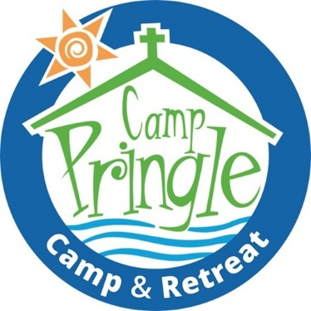 LIFEGUARD
Purpose and Scope of Work
The Lifeguard is responsible for the overall safety and enjoyment of the waterfront by campers, staff and volunteers. The Waterfront Director oversees the use and the maintenance of the waterfront activities and equipment and provides leadership, instructions in uses of the waterfront to lifeguard/s, campers, staff and volunteers. The waterfront director also acts as an on-duty lifeguard along with the other waterfront staff.

The Lifeguard coordinates the waterfront activities in consultation with the Waterfront Director, the Summer Camp director and the Executive Director.

RESPONSIBILITIES
- Supervise all swimming and boating activities to ensure the safety of campers, staff and volunteers.
- Instructs campers in water safety, beach area and boating skills, leads recreational activities at the waterfront.
- Under the supervision of the Waterfront Director is also responsible for the overall safety, security and upkeep of the waterfront, and its facilities and equipment.
- Have an understanding and practical knowledge of the Camps 2026 curriculum.
- Respect and responsibility for ensuring alignment of the program with the vision and values of United Church Camping, Cap Pringle and ensuring the safety of participants.
- Maintain high levels of staff morale and conduct by providing mentorship and support to staff and volunteers.
- To actively participate and assist in the whole camp activities, such as campfires, wide games, mealtimes, vespers, welcoming campers, bedtime stories, assisting cabin leaders with their campers at night and mealtimes.

EDUCATION, TRAINING AND EXPERIENCE
- Previous experience with outdoor camping is an asset
- Experience in collaborative team leadership
  - Experience in a faith-based environment
  - Computer skills an asset
Certification: Applicants must have up-to-date certifications or be willing to complete certification prior to starting work for summer 2026.
- Standard First Aid
- First Aid & CPR/AED Level C certificate
- Bronze Cross Certification
- National Lifeguard Certification (NLG Service Pool)
- Small Boat Operators’ certification
- Mental Health First Aid (for People Working with Youth)
- Commit to Kids
- Godly Play Training (training dates are limited – a willingness to participate if able is required).
- YMCA Responsible Adult certification (an asset)
Ideal/Desired Certification
- Current RCA BC Advanced Solo/Tandem Canoe certification
- NLS (Waterpark, WSI (Water safety Instructor) and LSI Life Saving Instructor certification
- Swim Instructor Certification asset

COMPENSATION The remuneration for this salaried position will be based on the applicant’s experience, and between $19-$21 per hour. This position is 40 hours per week from June 8th until August 7th, 2026. Accommodation and meals will be provided during the weeks of summer camp (day camp and overnight camps).
APPLICATION PROCESS Applications will open January 5, 2026. Deadline for applications is, January 20th, 2026. Click or copy this link to take you to our website to apply. Summer Jobs | Camp Pringle 1

APPENDIX A
Camping Teamwork Schedule - Summer 2026
Date | Positions | Location | Information
Monday May 18th | Camp Director | Camp Pringle | Work travel and accommodation costs are paid for employees as per the Camping Staff Policies
Sunday May 31 to Thursday June 4th | Camp Director and Executive Director | Grafton near Kamloops | Training
Mon June 29-Frid July 3rd | Start Date for Counsellors, Camp and Program Director | Camp Pringle | Training Week - All summer staff are required to be there for the entirety of the week. Youth Crew to be there Thursday and Friday  Schedule of Hours – TBC  Other Regional groups will be in attendance
Mon. July 6-Thurs. July 10th | All Camp Pringle Staff and youth crew | Camp Pringle | Day camp – 6-8 years old and 9-11 9am-4pm  Overnight camp for 8-11
Monday July 13 – Friday July 17 | All Staff | Camp Pringle | Day Camp 6-8/ 9-119am-4pm  Overnight Camp 12-14 yr
Mon July 20 – Friday July 24 | All Staff | Camp Pringle | Day 6-8/12-14 9am-4pm  Overnight 8-11
Monday July 27 – Friday July 31 | All Staff | Camp Pringle | Day Camp 6-8/ 9-11 /12-14 9am-4pm  No Overnight
Monday Aug 3 -Friday Aug 7th | All Staff | Camp Pringle | Day Camp 6-8 / 9-11 9am-4pm  Overnight 8-11

